Final assessment test
- A hospital has asked for a program that will control the order in which the arrivals are seen in the accident and emergency department.
(a) A priority queue has been chosen to store the arrival information.
(i) State the property of a priority queue that makes it suitable for this application. [1]
FIFO

(ii) The priority queue is implemented using a circular queue.
State an advantage of a circular queue which makes it more efficient in use of memory. [1]
cIRCular queues wraparound so no time wasted

(b) A test version of the priority circular queue consists of 5 cells. Arrival information consists of a severity rating and a last name. The severity scale is 3 (least severe), 2 (moderately severe), and 1 (most severe). For example, Mr Jones has a severity rating of 2. His arrival record would be ‘2 Jones’.
Complete the diagram to show the results after the following operations. [4]
Note: The first element in the queue has an index of 0.

 | Arrivals
 | [0] | [1] | [2] | [3] | [4] | count | front |  | rear |  |  | returned
 | 1 Black | 1 Singh | 2 Jones | 3 Reeve |  | 4 | 0 |  | 3
Dequeue |  | 1 singh | 2 jones | 3reeve |  | 3 | 1 |  | 3 |  |  | 1 black
Enqueue ‘3 Mason’ |  | 1 singh | 2 jones | 3reeve | 3 mason | 4 | 1 |  | 4 |  |  | 1balck
Enqueue ‘2 Ing’ | 2 ing | 1 singh | 2 jones | 3reeve | 3 mason | 5 | 1 |  | 0 |  |  | 1 black
Dequeue | 2 ing |  | 2 jones | 3reeve | 3 mason | 4 | 2 |  | 0 |  |  | 1 singh
- A stack is an important data structure in computer science.
(a) Define the term stack. [2]

(b) A call stack is used when subroutines are called.
List 3 items that each call stack frame could hold. [3]

(c) Explain how a recursive algorithm could cause a system to crash. [2]

(d) State another use of a stack in a computing system. [1]

- In a very busy coffee shop, orders are split between different production lines. One line only makes hot drinks. Another line only makes cold drinks. When an order arrives, items are split out and assigned to different lines. Items are given to customers as soon as the order is complete. An abstract data type list is used to hold the order IDs.
(a) Describe the difference between a dynamic and a static data structure. [2]

(b) Identify a check that should be done before removing an item (popping) from a list. [1]

(c) Identify 2 pieces of information from the scenario that are important in deciding whether to implement the order lists as dynamic or static data structures. [2]

- Hashing is often used when large amounts of data need to be stored.
(a) Explain how a hashing algorithm works. [3]

(b) A particular hashing algorithm sums all the individual digits in a number and takes the remainder after division by 11 as the address in the hash table. Apply this algorithm to 7823901. [1]

(c) In the following hash table, collision resolution is done by storing the item in the next free slot.

[0]
[1]
[2] | Jones
[3] | Wilson
[4] | Smith
[5] | Brown
[6]
[7]
[8] | Green
[9]
[10] | Gold

(i) The value “Redmond” needs to be added to the table. The hash value is 6.
State the value of the table index where “Redmond” is stored. [1]

(ii) The value “Farmer” needs to be added to the table. The hash value is 10.
State the value of the table index where “Farmer” is stored. [1]

(d) The performance of a particular large hash table has degraded as the table fills up.
(i) Explain why this might be the case. [1]

(ii) Explain one possible way of improving the performance of the hash table. [2]

- Towns and the connections between them can be represented as a graph which has a set of nodes connected by edges. This representation is an abstraction.
(a) Define the term data abstraction. [2]

(b) Complete the adjacency list for this graph. [2]
A
B
C
D
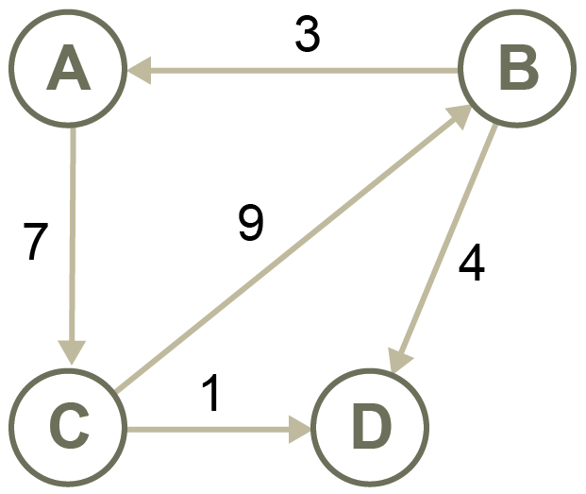
(c) Complete the adjacency matrix for this graph. [2]
 | A | B | C | D
A
B
C
D
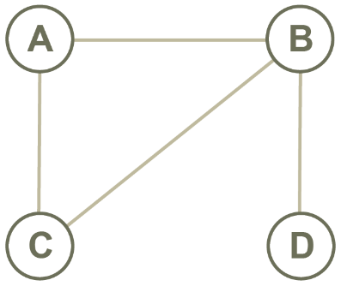

- A tree is an abstract data type.
(a) Define the term tree. [2]

(b) Here is a binary tree.
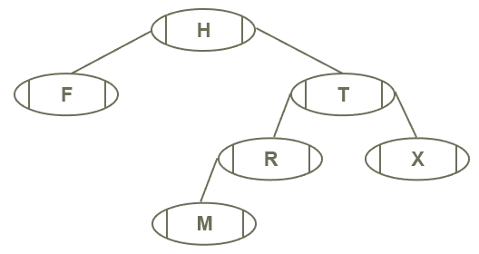

- Complete the array implementation of this tree. [2]
 | left | data | right
A[0] | 3 | H | 1
A[1]
A[2] | 5 | R | -1
A[3] | -1 | F | -1
A[4] | -1 | X | -1
A[5]

(ii) List the nodes in the order in which they are visited for each traversal. [3]
Pre-order:
In-order:
Post-order:
(c) Add the following items to a binary tree so that it may be quickly searched to find a particular item:
Liam, Mary, Zoe, Carla, David, Lucy, Adam [2]

- Scalars have only magnitude. Vectors have both magnitude and direction. Mathematical operations can be used to combine vectors and scalars.
(a) Here are two vectors:
a = (6, -1) b = (-3, -3)
- Calculate the result of a + b. Show your working. [1]

(ii) Calculate the magnitude of vector b. Show your working. [1]

(b) Vector u is defined as (4, 2).
(i) Calculate 4u. Show your working. [1]

- What is the effect of multiplying a vector by a scalar? [1]

(c) p = [4, 3, 2, 1] represents the count of people completing the number of laps around a field, expressed in f = [10, 20, 30, 40].
Determine the total laps by calculating p • f. Show your working. [1]

(d) Dot product can be used to calculate even parity.
u = [1, 1, 1, 1] and v = [1, 0, 0, 1].
Determine the parity bit by calculating u • v. [2]

Total 50 marks

